EGE593-01: Functional Verification of Hardware Systems

**LC3 Microcontroller**

**(Fetch and Decode modules)**

|  |  |
| --- | --- |
| Group Members | **Department** |
| **Adam Secovine** | **CE** |
| **Ivan Vivar** | **CE** |

**Course Professor: Rajeev Narayanan**

**Date: 11/7/14**

Table of Contents

Objective 3

Functional Coverage 4

Fetch Bugs 5

Decode Bugs 7

Appendix A 11

Fetch 12

Fetch Block Test Cases 13

Case 1: Reset 13

Case 2: Update PC 13

Case 3: Hold PC 14

Case 4: Enable Instruction Memory Read Signal 14

Decode Block 15

Decode Block Test Cases 16

Case 1: Reset 16

Case 2: npc_in & npc_out 16

Case 3: Instr_dout & IR 17

Case 4: E_Control - ADD 17

Case 5: E_Control -ADDi 18

Case 6: E_Control – AND 18

Case 7: E_Control – ANDi 19

Case 8: E_Control - NOT 19

Case 9: E_Control - LEA 20

Case 10: W_Control - ADD 20

Case 11: W_Control - ADDi 21

Case 12: W_Control - AND 21

Case 13: W_Control - ANDi 22

Case 14: W_Control – NOT 22

Case 15: W_Control - LEA 23

Case 16: Enable_Decode 23

Appendix B 24

# Objective

Familiarize ourselves with the functionality and the specifications of the unpipelined LC-3 microcontroller and to conduct a functional verification on a portion of the microprocessor design. The LC-3 microcontroller consists of a Fetch, Decode, Execute and Write Back block. Our portion of focus on the LC-3 is the Fetch and Decode blocks. Although the LC-3 has a large instruction set we will only be focusing on the following six: ADD, ADDi, AND, ANDi, NOT, LEA. These instructions are relevant to the functioning of the Decode block, while the Fetch block is primarily concerned with the proper incrementing for the program counter. In order to properly test the functionality of these blocks, we first developed a detailed test plan; then, we implemented this test plan using SystemVerilog.

Procedure

As mentioned, as a first step in the verification of the Fetch and Decode modules of the LC-3, we developed a detailed test plan, in which we outline the different case to be tested. These cases were dictated by the specification provided. The full test plan of the two blocks mentioned can be seen in Appendix A. Given the limited nature of these blocks, the plan itself is primarily linear, with only minor use of random values.

Beyond the test plan, we were also interested in achieving maximum functional coverage for both of these blocks. To accomplish this, we created two cover groups, each with bins specific to the inputs to the block being tested. These cover groups can be found in the blocks’ respective test benches.

We were also concerned with properly recording the bugs found in each module, according to the particular test cases. For this, a package, containing two classes (one for each block being tested), was written. Each class references a struct which contains the inputs and outputs specific to the block being tested. As each error is encountered within the tasks of each testbench, the values of all I/Os, at the time of the error, are recorded into a new struct, and that struct is appended onto a queue of error structs.

The complete code for each testbench, the ‘testing.sv’ package, and the top modules associated with each block to be tested can be seen in Appendix B.

Results

This section includes the results of the testbenches created for the Fetch and Decode modules of the LC3 microcontroller and lists the bugs found within the respective module. The tests’ functional coverage is also listed.

## Functional Coverage

Given the limited nature of the blocks to be tested, functional coverage of 100% was expected, and achieved. Figure 1 and Figure 2 show these results, as well as the particular bins created for each covergroup.

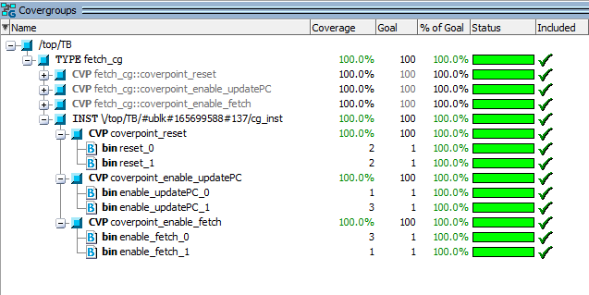

Figure 1: Functional Coverage for Fetch Block

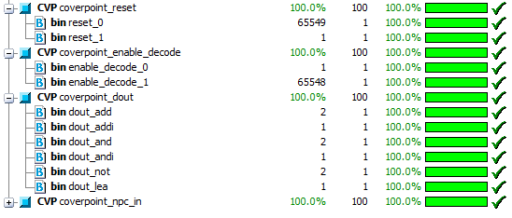

Figure 2: Functional Coverage for Decode Block

As the *npc_in* signal (input to the Decode block) is 16-bits long, individual bins were not created, with auto-bins allowed. The overall coverpoint was measured to be 100%, along with all of the other coverpoints measured for both blocks.

## Fetch Bugs

Below, the scoreboard report of the Fetch block can be seen (Figure 4).

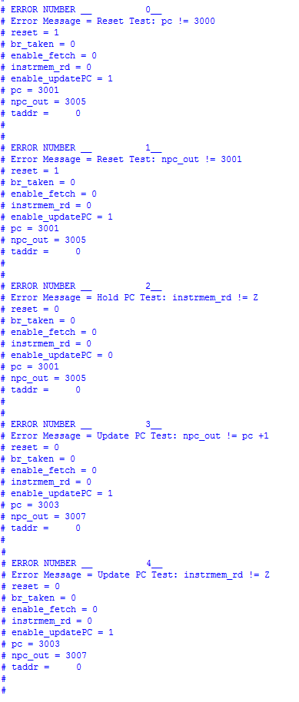

Figure 3: Fetch Scoreboard

An explanation of the bugs found can be seen below, in Table1 through Table 4.

Table 1: Fetch Reset Test Bug 1

|  |  |
| --- | --- |
| Error in: | Reset Test |
| Specification (Expected Value) | pc = 0x3000 |
| Test Bench (Received Value) | pc = 0x3001 |
| Error description: | On reset, the value of pc should be 0x3000, but is instead read as 0x3001 |

Table 2: Fetch Reset Test Bug 2

|  |  |
| --- | --- |
| Error in: | Reset Test |
| Specification (Expected Value) | npc = 0x3001 |
| Test Bench (Received Value) | npc = 0x3005 |
| Error description: | While the npc is expected to be pc + 1, it is consistently seen to be pc + 4 |

Table 3: Fetch Hold PC Test Bug

|  |  |
| --- | --- |
| Error in: | Hold PC Test |
| Specification (Expected Value) | instrmem_rd = Z |
| Test Bench (Received Value) | instrmem_rd = 0 |
| Error description: | The instrmem_rd line is expected to be high-impedance (Z) when the enable_updatePC line is held low (0), but is instead putting out a value of zero. |

Table 4: Fetch Update PC Test Bug

|  |  |
| --- | --- |
| Error in: | Update PC Test |
| Specification (Expected Value) | pc = pc + 1 |
| Test Bench (Received Value) | pc = pc + 2 |
| Error description: | Given the enable_updatePC high, pc should be incremented by 1, but is seen to be incremented by 2. |

## Decode Bugs

Below, the scoreboard report of the Decode block can be seen (Figure 4).

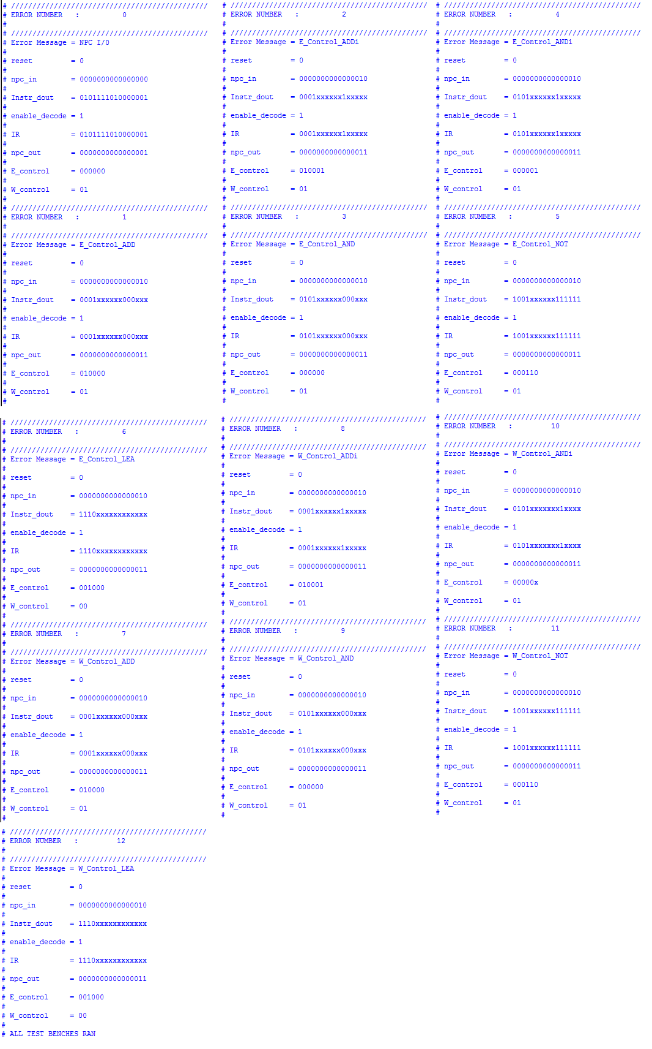

Figure 4: Decode Scoreboard

An explanation of the bugs found can be seen below, in Table 5 through Table 13.

Table 5: Decode NPC I/O Test Bug

|  |  |
| --- | --- |
| Error in: | npc_in & npc_out |
| Specification (Expected Value) | npc_in = npc_out |
| Test Bench (Received Value) | npc_out = npc_in + 1 |
| Error description: | npc_in gets added a one somewhere, incrementing itself and npc_out. |

Table 6: Decode W_Control Test Bug 1

|  |  |
| --- | --- |
| Error in: | W_Control – ALU Operations (ADD,ADDi,AND,ANDi,NOT) |
| Specification (Expected Value) | W_Control = 00 |
| Test Bench (Received Value) | W_Control = 01 |
| Error description: | W_Control is ‘1’ instead of ‘0’ |

Table 7: Decode W_Control Test Bug 2

|  |  |
| --- | --- |
| Error in: | W_Control – LEA |
| Specification (Expected Value) | W_Control = 10 |
| Test Bench (Received Value) | W_Control = 00 |
| Error description: | W_Control is ‘0’ instead of ‘2’ |

E_Control is the concatenation (from MSB to LSB) of the alu_control (2 bits), pcselect1 (2bits), pcselect2 (1 bit) and op2select (1 bit) signal. See figure below for visual description.

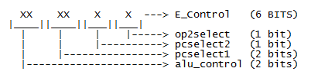

Table 8: Decode E_Control_ADD Test Bug

|  |  |
| --- | --- |
| Error in: | E_Control – ADD |
| Specification (Expected Value) | E_Control = 00XXX1 |
| Test Bench (Received Value) | E_Control = 01XXX0 |
| Error description: | The alu_control bits is ‘1’ instead of ‘0’  The op2select bit is ‘0’ instead of ‘1’ |

Table 9: Decode E_Control_ADDi Test Bug

|  |  |
| --- | --- |
| Error in: | E_Control - ADDi |
| Specification (Expected Value) | E_Control = 00XXX0 |
| Test Bench (Received Value) | E_Control = 01XXX1 |
| Error description: | The alu_control bits is ‘1’ instead of ‘0’  The op2select bit is ‘1’ instead of ‘0’ |

Table 10: Decode E_Control_AND Test Bug

|  |  |
| --- | --- |
| Error in: | E_Control – AND |
| Specification (Expected Value) | E_Control = 01XXX1 |
| Test Bench (Received Value) | E_Control = 00XXX0 |
| Error description: | The alu_control bits is ‘0’ instead of ‘1’  The op2select bit is ‘0’ instead of ‘1’ |

Table 11: Decode E_Control_ANDi Test Bug

|  |  |
| --- | --- |
| Error in: | E_Control - ANDi |
| Specification (Expected Value) | E_Control = 01XXX1 |
| Test Bench (Received Value) | E_Control = 00XXX0 |
| Error description: | The alu_control bits is ‘0’ instead of ‘1’  The op2select bit is ‘0’ instead of ‘1’ |

Table 12: Decode E_Control_NOT Test Bug

|  |  |
| --- | --- |
| Error in: | E_Control - NOT |
| Specification (Expected Value) | E_Control = 10XXXX |
| Test Bench (Received Value) | E_Control = 00XXXX |
| Error description: | The alu_control bits is ‘0’ instead of ‘2’ |

Table 13: Decode E_Control_LEA Test Bug

|  |  |
| --- | --- |
| Error in: | E_Control - LEA |
| Specification (Expected Value) | E_Control = XX011X |
| Test Bench (Received Value) | E_Control = XX100X |
| Error description: | The alu_control bits is ‘0’ instead of ‘2’ |

Conclusion

Fortunately, finding the bugs within these blocks was relatively straight forward. Creating a detailed test plan prior to writing our code greatly improved the speed with which we were able to complete the test bench, and ensured that we addressed all aspects of the specification thoroughly. By using SystemVerilog object-oriented functionality, such as packages, classes, covergroups, functions, and tasks, we were able to keep the code succinct and functionally compartmentalized. Given the ever increasing complexity and variety of today’s logic designs, the ability to properly verify the specifications of said designs is an increasingly important piece of digital hardware design, making the skills gained in this project highly valuable in today’s market.

# Appendix A

LC-3

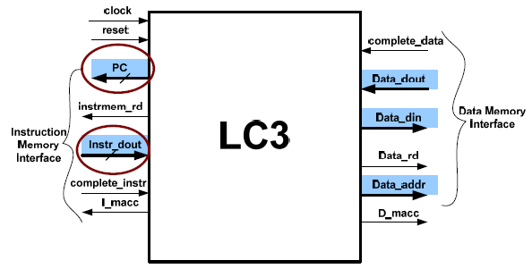

Figure 1: Top Level Block Diagram of LC-3

The input and output pins of the Design Under Test (DUT), LC-3 are listed below.

* **Inputs**
  + **clock** (1 bit)
  + **reset** (1 bit)
  + **complete_data** (1 bit)
  + **complete_instr** (1 bit)
  + **Instr_dout** (16 bits): Carries the Instruction from the Instruction Memory interface into the LC-3.
  + Data_dout (Ignore for this project)
* **Outputs**
  + **PC** (16 bits): The Program Counter contains the addres to the Instruction Memory.
  + **instrmem_rd** (1 bit): The read enable signal for the Instruction Memory. Fetches an instruction.
  + Data_addr (Ignored in this project)
  + **Data_din** (16 bit):
  + **Data_rd** (1 bit)
  + I_macc (Ignored in this project)
  + D_macc (Ignored in this project)

# Fetch

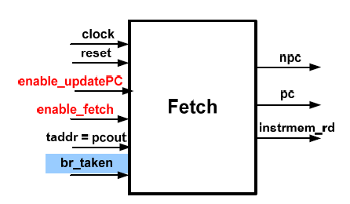

Figure 2: Top Level Block Diagram for Fetch

The inputs and output pins of the **Fetch Block** are listed below:

* **Inputs**
  + **clock** (1 bit)
  + **reset** (1 bit)
  + **enable_updatePC** (1 bit): When 1’b1 the PC changes at the positive edge of the clock to PC+1 or taddr based on br_taken.
  + **enable_fetch** (1 bit): When 1’b1 the fetching (reading) of the Instruction Memory is conducted.
  + br_taken (Ignored in this project)
  + taddr (Ignored for this project)
* **Outputs**
  + **intrmem_rd** (1 bit): An asynchronous signal enabled when *enable_fetch* is 1’b1 and it tells the Memory that a read rather than a write is to be conducted
  + **pc** (16 bits): The Program Counter’s current value.
  + **nps** (16 bits): Is an asynchronous signal that is equal to PC+1.

# Fetch Block Test Cases

This section introduces the list of test cases for the Fetch module which will later allow us to build test benches off of.

## Case 1: Reset

Purpose: Test of the reset functionality. Inputs set as “X” will be provided random values over multiple clock cycles.

**Inputs Signals**

* Clock: Running
* Reset: 1’b1
* enable_updatePC: 1’bX
* enable_fetch: 1’bX

**Expected Outputs - T1**

* pc: 16’h3000
* npc: 16’h3001
* instrmem_rd: 1’bX

## Case 2: Update PC

Purpose: To test the normal operation of the block, without reset, with fetch disabled.

**Inputs Signals**

* Clock: Running
* Reset: 1’b0
* enable_updatePC: 1’b1
* enable_fetch: 1’b0

**Expected Outputs - T0**

* pc: 16’h3000
* npc: 16’h3001
* instrmem_rd: 1’bZ

**Expected Outputs - T1**

* pc: 16’h3001
* npc: 16’h3002
* instrmem_rd: 1’bZ

**Expected Outputs - T2**

* pc: 16’h3002
* npc: 16’h3003
* instrmem_rd: 1’bZ

## Case 3: Hold PC

Purpose: To test whether the block will hold the same pc and npc values when enable_updatePC is disabled.

**Inputs Signals**

* Clock: Running
* Reset: 1’b0
* enable_updatePC: 1’b0
* enable_fetch: 1’b0

**Expected Outputs - T0**

* pc: 16’h3000
* npc: 16’h3001
* instrmem_rd: 1’bZ

**Expected Outputs - T1**

* pc: 16’h3000
* npc: 16’h3001
* instrmem_rd: 1’bZ

**Expected Outputs - T2**

* pc: 16’h3000
* npc: 16’h3001
* instrmem_rd: 1’bZ

## Case 4: Enable Instruction Memory Read Signal

Purpose: The test whether the instrmem_rd signal will output HIGH when enabled.

**Inputs Signals**

* Clock: Running
* Reset: 1’bX
* enable_updatePC: 1’bX
* enable_fetch: 1’b1

**Expected Outputs - T0**

* pc: 16’h3000
* npc: 16’h3001
* instrmem_rd: 1’b1

# Decode Block

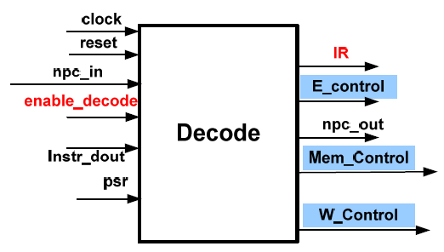

Figure 3: Top Level Block Diagram of Decode

The Input and output pins of the **Decode Block** are listed below:

* **Inputs**
  + **clock** (1 bit)
  + **reset** (1 bit)
  + **npc_in** (16 bit): The npc value taken from the Fetch block and is passed along the pipeline to its final consuming block.
  + **Instr_dout** (16 bit): Carries the Instruction from the Instruction Memory
  + **enable_decode** (1 bit): When 1’b1 it allows for the operation of the decode unit in normal mode where it creates the relevant control signals at the output based on the input from the Instruction Memory. If it is 1’b0 then the Decode block stalls and does not change the output.
  + psr (Ignore for this project)
* **Outputs**
  + **IR** (16 bits): equal to *Instr_dout*.
  + **npc_out** (16 bits): equal to *npc_in*.
  + **E_control** (6 bits): This signal controls the Execute Block.
  + **W_control** (2 bits): This signal controls the Writeback Block and decides where to write to the *RegFile*.
  + Mem_control (Ignored for this project)

# Decode Block Test Cases

This section introduces the list of test cases for the Decode module which will later allow us to build test benches off of.

## Case 1: Reset

Purpose: Test of the reset functionality

* **Inputs**
  + clock: Running
  + reset: 1’b1
  + npc_in: 16’bX
  + Instr_dout: 16’bX
  + enable_decode: 1’bX

* **Outputs** 
  + IR: 1’b0
  + npc_out: 1’b0
  + E_control: 1’b0
  + W_control: 1’b0

## Case 2: npc_in & npc_out

Purpose: In this case we are assuming the input npc_in and npc_out are the same value. We are testing that the enable bit controlled by the enable_decode signal is enabled and the npc_out value holds the previous value of npc_in.

* **Inputs**
  + clock: Running
  + reset: 1’b0
  + npc_in: 16’h1010
  + Instr_dout: 16’hXXXX
  + enable_decode: 1’b1

* **Outputs** 
  + IR: 16’hXXXX
  + npc_out: 16’h1010
  + E_control: 6’bXXXXXX
  + W_control: 1’bX

## Case 3: Instr_dout & IR

Purpose: In this case we are assuming the input Instr_dout and IR are the same value. We are testing that the enable bit controlled by the enable_decode signal is disabled and the Instr_dout holds the previous value of IR.

* **Inputs**
  + clock: Running
  + reset: 1’b0
  + npc_in: 16’hXXXX
  + Instr_dout: 16’h1010
  + enable_decode: 1’b1

* **Outputs** 
  + IR: 16’h1010
  + npc_out: 16’hXXXX
  + E_control: 6’bXXXXXX
  + W_control: 2’bXX

## Case 4: E_Control - ADD

Purpose: To test that the right combination of the IR[15:12] and IR[5] bits within Instr_dout[15:0] to produce the right E_Control combination to produce ADD.

* **Inputs**
  + clock: Running
  + reset: 1’b0
  + npc_in: 16’hXXXX
  + Instr_dout: 16’b**0001**XXXXXX**0**00XXX
  + enable_decode: 1’b1

* **Outputs** 
  + IR: 16’b**0001**XXXXXX**0**00XXX
  + npc_out: 16’hXXXX
  + E_control: 6’b**00**XXX**1**
  + W_control: 2’bXX

## Case 5: E_Control -ADDi

Purpose: To test that the right combination of the IR[15:12] and IR[5] bits within Instr_dout[15:0] to produce the right E_Control combination to produce ADD immediate.

* **Inputs**
  + clock: Running
  + reset: 1’b0
  + npc_in: 16’hXXXX
  + Instr_dout: 16’b**0001**XXXXXX**1**XXXXX
  + enable_decode: 1’b1

* **Outputs** 
  + IR: 16’b**0001**XXXXXX**1**XXXXX
  + npc_out: 16’hXXXX
  + E_control: 6’b**00**XXX**0**
  + W_control: 2’bXX

## Case 6: E_Control – AND

Purpose: To test that the right combination of the IR[15:12] and IR[5] bits within Instr_dout[15:0] to produce the right E_Control combination to produce AND.

* **Inputs**
  + clock: Running
  + reset: 1’b0
  + npc_in: 16’hXXXX
  + Instr_dout: 16’b**0101**XXXXXX**0**00XXX
  + enable_decode: 1’b1

* **Outputs** 
  + IR: 16’b**0101**XXXXXX**0**00XXX
  + npc_out: 16’hXXXX
  + E_control: 6’b**01**XXX1
  + W_control: 2’bXX

## Case 7: E_Control – ANDi

Purpose: To test that the right combination of the IR[15:12] and IR[5] bits within Instr_dout[15:0] to produce the right E_Control combination to produce AND immediate.

* **Inputs**
  + clock: Running
  + reset: 1’b0
  + npc_in: 16’hXXXX
  + Instr_dout: 16’b**0101**XXXXXX**1**XXXXX
  + enable_decode: 1’b1

* **Outputs** 
  + IR: 16’b**0101**XXXXXX**1**XXXXX
  + npc_out: 16’hXXXX
  + E_control: 6’b**01**XXX**0**
  + W_control: 2’bXX

## Case 8: E_Control - NOT

Purpose: To test that the right combination of the IR[15:12] and IR[5] bits within Instr_dout[15:0] to produce the right E_Control combination to produce NOT immediate.

* **Inputs**
  + clock: Running
  + reset: 1’b0
  + npc_in: 16’hXXXX
  + Instr_dout: 16’b**1001**XXXXXX**111111**
  + enable_decode: 1’b1

* **Outputs** 
  + IR: 16’b**1001**XXXXXX**111111**
  + npc_out: 16’hXXXX
  + E_control: 6’b**10**XXX**X**
  + W_control: 2’bXX

## Case 9: E_Control - LEA

Purpose: To test that the right combination of the IR[15:12] and IR[5] bits within Instr_dout[15:0] to produce the right E_Control combination to produce LEA immediate.

* **Inputs**
  + clock: Running
  + reset: 1’b0
  + npc_in: 16’hXXXX
  + Instr_dout: 16’b**1110**XXXXXXXXXXXX
  + enable_decode: 1’b1

* **Outputs** 
  + IR: 16’b**1110**XXXXXXXXXXXX
  + npc_out: 16’hXXXX
  + E_control: 6’bXX**111**X
  + W_control: 2’bXX

## Case 10: W_Control - ADD

Purpose: To test that the right combination of the IR[15:12] bits and MODE bit produces the right W_Control combination to produce ADD.

* **Inputs**
  + clock: Running
  + reset: 1’b0
  + npc_in: 16’hXXXX
  + Instr_dout: 16’b**0001**XXXXXXX**0**00XXX
  + enable_decode: 1’b1

* **Outputs** 
  + IR: 16’b**0001**XXXXXXX**0**00XXX
  + npc_out: 16’hXXXX
  + E_control: 16’hXXXX
  + W_control: 2’b**00**

## Case 11: W_Control - ADDi

Purpose: To test that the right combination of the IR[15:12] bits and MODE bit produces the right W_Control combination to produce ADD immediate.

* **Inputs**
  + clock: Running
  + reset: 1’b0
  + npc_in: 16’hXXXX
  + Instr_dout: 16’b**0001**XXXXXX**1**XXXXX
  + enable_decode: 1’b1

* **Outputs** 
  + IR: 16’b**0001**XXXXXX**1**XXXXX
  + npc_out: 16’hXXXX
  + E_control: 16’hXXXX
  + W_control: 2’b**00**

## Case 12: W_Control - AND

Purpose: To test that the right combination of the IR[15:12] bits and MODE bit produces the right W_Control combination to produce AND.

* **Inputs**
  + clock: Running
  + reset: 1’b0
  + npc_in: 16’hXXXX
  + Instr_dout: 16’b**0101**XXXXXX000XXX
  + enable_decode: 1’b1

* **Outputs** 
  + IR: 16’b**0101**XXXXXX000XXX
  + npc_out: 16’hXXXX
  + E_control: 16’hXXXX
  + W_control: 2’b**00**

## Case 13: W_Control - ANDi

Purpose: To test that the right combination of the IR[15:12] bits and MODE bit produces the right W_Control combination to produce AND immediate.

* **Inputs**
  + clock: Running
  + reset: 1’b0
  + npc_in: 16’hXXXX
  + Instr_dout: 16’b**0101**XXXXXX**1**XXXXX
  + enable_decode: 1’b1

* **Outputs** 
  + IR: 16’b**0101**XXXXXX**1**00XXX
  + npc_out: 16’hXXXX
  + E_control: 16’hXXXX
  + W_control: 2’b**00**

## Case 14: W_Control – NOT

Purpose: To test that the right combination of the IR[15:12] bits and MODE bit produces the right W_Control combination to produce AND immediate.

* **Inputs**
  + clock: Running
  + reset: 1’b0
  + npc_in: 16’hXXXX
  + Instr_dout: 16’b**1001**XXXXXX**111111**
  + enable_decode: 1’b1

* **Outputs** 
  + IR: 16’b**1001**XXXXXX**111111**
  + npc_out: 16’hXXXX
  + E_control: 16’hXXXX
  + W_control: 2’b**00**

## Case 15: W_Control - LEA

Purpose: To test that the right combination of the IR[15:12] bits and MODE bit produces the right W_Control combination to produce AND immediate.

* **Inputs**
  + clock: Running
  + reset: 1’b0
  + npc_in: 16’hXXXX
  + Instr_dout: 16’b**1110**XXXXXXX**XXXXXX**
  + enable_decode: 1’b1

* **Outputs** 
  + IR: 16’b**1110**XXXXXXX**XXXXXX**
  + npc_out: 16’hXXXX
  + E_control: 16’hXXXX
  + W_control: 2’b**10**

## Case 16: Enable_Decode

Purpose: The purpose of this test is to verify that the decode module does not create outputs when it is disabled. A random number will be passed to npc_in and instr_dout. The outputs IR and npc_out will be checked and should not equal npc_in and instr_dout.

* **Inputs**
  + clock: Running
  + reset: 1’b0
  + npc_in: 16’hXXXX
  + Instr_dout: 16’b**1110**XXXXXXX**XXXXXX**
  + enable_decode: 1’b1

* **Outputs** 
  + IR: 16’b**1110**XXXXXXX**XXXXXX**
  + npc_out: 16’hXXXX
  + E_control: 16’hXXXX
  + W_control: 2’bXX

# Appendix B

/*testing.sv*/

package testing;

//*******************STRUCT FOR FETCH ERRORS*******************************************************************

typedef struct {

string er_msg;

reg reset;

reg br_taken;

reg enable_fetch;

reg instrmem_rd;

reg enable_updatePC;

reg [15:0] taddr;

reg [15:0] pc;

reg [15:0] npc_out;

} fetch_struct;

//*******************STRUCT FOR DECODE ERRORS*******************************************************************

typedef struct{

string er_msg;

reg reset;

reg [15:0] npc_in;

reg [15:0] Instr_dout;

reg enable_decode;

reg [15:0] IR;

reg [15:0] npc_out;

reg [5:0] E_control;

reg [1:0] W_control;

} decode_struct;

//******************CLASS FOR RECORDING DECODE ERRORS********************************************************************

class decode_error_rec;

integer unsigned error_count = 0;

decode_struct ds;

decode_struct error_queue[$];

function void incr_error(

string er_msg,

input reset,

input [15:0] npc_in,

input [15:0] Instr_dout,

input enable_decode,

input [15:0] IR,

input [15:0] npc_out,

input [5:0] E_control,

input [1:0] W_control

);

ds = '{er_msg,reset,npc_in,Instr_dout,enable_decode,IR,npc_out,E_control,W_control};

error_queue.push_back(ds);

error_count = (error_count + 1);

endfunction

function void report_errors();

foreach(error_queue[i]) begin

$display("//////////////////////////////////////////////");

$display("ERROR NUMBER :%d \n",i);

$display("//////////////////////////////////////////////");

$display("Error Message = %s \n",error_queue[i].er_msg);

$display("reset = %b \n",error_queue[i].reset);

$display("npc_in = %b \n",error_queue[i].npc_in);

$display("Instr_dout = %b \n",error_queue[i].Instr_dout);

$display("enable_decode = %b \n",error_queue[i].enable_decode);

$display("IR = %b \n",error_queue[i].IR);

$display("npc_out = %b \n",error_queue[i].npc_out);

$display("E_control = %b \n",error_queue[i].E_control);

$display("W_control = %b \n",error_queue[i].W_control);

end

endfunction

endclass //END decode_error_rec()

//******************CLASS FOR RECORDING FETCH ERRORS********************************************************************

class error_rec;

integer unsigned error_count = 0;

fetch_struct fs;

fetch_struct error_queue[$];

function void incr_error(

string er_msg,

input reset,

input br_taken,

input enable_fetch,

input instrmem_rd,

input enable_updatePC,

input [15:0] pc,

input [15:0] npc_out,

input [15:0] taddr

);

string error_string = string'(er_msg);

fs = '{er_msg,reset,br_taken,enable_fetch,instrmem_rd,enable_updatePC,taddr,pc,npc_out};

error_queue.push_back(fs);

error_count = (error_count + 1);

endfunction

function void report_errors();

foreach(error_queue[i]) begin

$display("ERROR NUMBER __%d__",i);

$display("Error Message = %s",error_queue[i].er_msg);

$display("reset = %d",error_queue[i].reset);

$display("br_taken = %d",error_queue[i].br_taken);

$display("enable_fetch = %d",error_queue[i].enable_fetch);

$display("instrmem_rd = %d",error_queue[i].instrmem_rd);

$display("enable_updatePC = %d",error_queue[i].enable_updatePC);

$display("pc = %h",error_queue[i].pc);

$display("npc_out = %h",error_queue[i].npc_out);

$display("taddr = %d\n\n",error_queue[i].taddr);

end

endfunction

endclass //END error_rec()

//**************************************************************************************

endpackage

//**************************************************************************************

//**************************************************************************************

//**************************************************************************************

/*fetch_test.sv*/

`timescale 1ns/1ns

`include "C:/Users/n02549032/Desktop/Full_Code_Fetch_Decode/Full_Code_Fetch_Decode/testing.sv"

import testing::*;

module fetch_test(

output logic reset,

output logic br_taken,

output logic enable_fetch,

output logic enable_updatePC,

output logic [15:0] taddr,

input bit [15:0] pc,

input bit [15:0] npc_out,

input logic instrmem_rd,

input bit clock

);

integer last_pc;

//COVERGROUP **********************************************************

covergroup fetch_cg;

coverpoint_reset : coverpoint reset{

bins reset_0 = {0};

bins reset_1 = {1};

}

coverpoint_enable_updatePC : coverpoint enable_updatePC{

bins enable_updatePC_0 = {0};

bins enable_updatePC_1 = {1};

}

coverpoint_enable_fetch : coverpoint enable_fetch{

bins enable_fetch_0 = {0};

bins enable_fetch_1 = {1};

}

endgroup

//****************************************************************************************

//RESET **********************************************************************************

task reset_task(

input enable_fetch_t,

input enable_updatePC_t,

fetch_cg cg_inst,

error_rec fetch_er

);

reset <= 1'b1;

enable_fetch <= enable_fetch_t;

enable_updatePC <= enable_updatePC_t;

#10;

cg_inst.sample();

// if((pc != 16'h3000)||(npc_out != 16'h3001))begin

if(pc != 16'h3000)begin

fetch_er.incr_error("Reset Test: pc != 3000",reset,br_taken,enable_fetch,instrmem_rd,enable_updatePC,pc,npc_out,16'h0000);

$display("Reset Test Failed\n");

end

if(npc_out != 16'h3001)begin

fetch_er.incr_error("Reset Test: npc_out != 3001",reset,br_taken,enable_fetch,instrmem_rd,enable_updatePC,pc,npc_out,16'h0000);

$display("Reset Test Failed\n");

end

endtask

//****************************************************************************************

//UPDATE PC ******************************************************************************

task update_pc_task(

fetch_cg cg_inst,

error_rec fetch_er

);

reset <= 1'b0;

enable_updatePC <= 1'b1;

enable_fetch <= 1'b0;

#10;

cg_inst.sample();

if(npc_out != (pc + 1))begin

fetch_er.incr_error("Update PC Test: npc_out != pc +1",reset,br_taken,enable_fetch,instrmem_rd,enable_updatePC,pc,npc_out,16'h0000);

$display("Update PC Test Failed\n");

end

if((instrmem_rd == 1) || (instrmem_rd == 0))begin

fetch_er.incr_error("Update PC Test: instrmem_rd != Z",reset,br_taken,enable_fetch,instrmem_rd,enable_updatePC,pc,npc_out,16'h0000);

$display("Update PC Test Failed\n");

end

endtask

//****************************************************************************************

//HOLD PC ********************************************************************************

task hold_pc_task(

fetch_cg cg_inst,

error_rec fetch_er

);

last_pc <= pc;

//$display("last_pc = %d",last_pc);

reset <= 1'b0;

enable_updatePC <= 1'b0;

enable_fetch <= 1'b0;

#10;

cg_inst.sample();

$display("pc = %d",pc);

if(pc != last_pc)begin

fetch_er.incr_error("Hold PC Test: pc != last_pc",reset,br_taken,enable_fetch,instrmem_rd,enable_updatePC,pc,npc_out,16'h0000);

$display("Hold PC Test Failed\n");

end

if((instrmem_rd == 1) || (instrmem_rd == 0))begin

fetch_er.incr_error("Hold PC Test: instrmem_rd != Z",reset,br_taken,enable_fetch,instrmem_rd,enable_updatePC,pc,npc_out,16'h0000);

$display("Hold PC Test Failed\n");

end

endtask

//****************************************************************************************

//ENABLE INSTRUCTION MEMORY READ SIGNAL **************************************************

task instr_mem_rd_task(

fetch_cg cg_inst,

error_rec fetch_er,

input reset_t,

input enable_updatePC_t

);

reset <= reset_t;

enable_updatePC <= enable_updatePC_t;

enable_fetch <= 1'b1;

#10;

cg_inst.sample();

if(instrmem_rd != 1'b1)begin

fetch_er.incr_error("Enable Instr Mem Read Test: instrmem_rd != 1",reset,br_taken,enable_fetch,instrmem_rd,enable_updatePC,pc,npc_out,16'h0000);

$display("Instruction Memory Read Test Failed\n");

end

endtask

//INITIAL **************************************************************

initial begin

error_rec fetch_er;

fetch_cg cg_inst;

fetch_er = new();

cg_inst = new();

br_taken <= 1'b0;

reset_task($random,$random,cg_inst,fetch_er);

hold_pc_task(cg_inst,fetch_er);

update_pc_task(cg_inst,fetch_er);

instr_mem_rd_task(cg_inst,fetch_er,$random,$random);

$display("The following errors were found:\n");

fetch_er.report_errors();

end

endmodule

//**************************************************************************************

//**************************************************************************************

//**************************************************************************************

/*DecodeTB.sv*/

//`include "C:/Users/n02549032/Desktop/Fetch_Code/testing.sv"

import testing::*;

module DecodeTB( input bit clock,

input logic [1:0] W_Control,

input logic [5:0] E_Control,

input logic [15:0] IR,

input logic [15:0] npc_out,

input logic Mem_Control,

output logic reset,

output logic enable_decode,

output logic [15:0] dout,

output logic [15:0] npc_in);

covergroup decode_covergroup;

coverpoint_reset : coverpoint reset{

bins reset_0 = {0};

bins reset_1 = {1};

}

coverpoint_enable_decode : coverpoint enable_decode{

bins enable_decode_0 = {0};

bins enable_decode_1 = {1};

}

coverpoint_dout : coverpoint dout{

bins dout_add = {16'b0001XXXXXX000XXX};

bins dout_addi = {16'b0001XXXXXX1XXXXX};

bins dout_and = {16'b0101XXXXXX000XXX};

bins dout_andi = {16'b0101XXXXXX1XXXXX};

bins dout_not = {16'b1001XXXXXX111111};

bins dout_lea = {16'b1110XXXXXXXXXXXX};

}

coverpoint_npc_in : coverpoint npc_in{

}

endgroup

initial begin

decode_covergroup decode_cg;

decode_error_rec dec_er;

decode_cg = new();

dec_er = new();

RST(decode_cg,dec_er);

NPCI_O(decode_cg,dec_er);

INSTR_IR(decode_cg,dec_er);

ED_Bit(decode_cg,dec_er);

EC_ADD(decode_cg,dec_er);

EC_ADDi(decode_cg,dec_er);

EC_AND(decode_cg,dec_er);

EC_ANDi(decode_cg,dec_er);

EC_NOT(decode_cg,dec_er);

EC_LEA(decode_cg,dec_er);

WC_ADD(decode_cg,dec_er);

WC_ADDi(decode_cg,dec_er);

WC_AND(decode_cg,dec_er);

WC_ANDi(decode_cg,dec_er);

WC_NOT(decode_cg,dec_er);

WC_LEA(decode_cg,dec_er);

dec_er.report_errors();

$display("ALL TEST BENCHES RAN");

end

//****************RESET*************************************

task RST(decode_covergroup decode_cg,decode_error_rec dec_er);

reset = 1'b1;

#10

npc_in <= $random;

dout <= $random;

enable_decode <= $random;

decode_cg.sample();

#20

if (IR != 1'b0 || npc_out != 1'b0 || E_Control != 1'b0 || W_Control != 1'b0) begin

dec_er.incr_error("RESET",reset,npc_in,dout,enable_decode,IR,npc_out,E_Control,W_Control);

end

reset = 1'b0;

endtask

//****************NPC I/0***********************************

task NPCI_O(decode_covergroup decode_cg,decode_error_rec dec_er);

static int i = 0;

enable_decode = 1'b1;

#10

repeat(65535)begin

npc_in <= i;

decode_cg.sample();

#20

if (npc_in != npc_out)

begin

dec_er.incr_error("NPC I/0",reset,npc_in,dout,enable_decode,IR,npc_out,E_Control,W_Control);

end

i = i + 1;

end

endtask

//************Instr_dout = dout & IR*******************************

task INSTR_IR(decode_covergroup decode_cg,decode_error_rec dec_er);

enable_decode = 1'b1;

#10

dout <= $random;

decode_cg.sample();

#20

if (dout != IR)

begin

dec_er.incr_error("Instr_dout",reset,npc_in,dout,enable_decode,IR,npc_out,E_Control,W_Control);

end

else

begin

$display("---------------------------------------------\n");

$display("Dout & IR is good");

$display("---------------------------------------------\n");

end

endtask

//*************Enable_Decode********************************

/* enable the enable bit, pass a value for npc_in and dout and then turn off the enable bit

pass it another value and then turn it on again.

*/

task ED_Bit(decode_covergroup decode_cg,decode_error_rec dec_er);

enable_decode <= 1'b1;

npc_in <= 16'h0000;

dout <= 16'hFFFF;

decode_cg.sample();

#20

enable_decode = 1'b0;

#10

npc_in <= 16'h0002;

dout <= 16'h0000;

decode_cg.sample();

#20

if((dout == IR)||(npc_in == npc_out))begin

dec_er.incr_error("Enable_Decode",reset,npc_in,dout,enable_decode,IR,npc_out,E_Control,W_Control);

end

endtask

//*************E_Control_ADD********************************

task EC_ADD(decode_covergroup decode_cg,decode_error_rec dec_er);

//repeat(5)

//begin

enable_decode = 1'b1;

#10

dout <= 16'b0001XXXXXX000XXX;

decode_cg.sample();

#20

if(E_Control != 6'b00XXX1 )

begin

dec_er.incr_error("E_Control_ADD",reset,npc_in,dout,enable_decode,IR,npc_out,E_Control,W_Control);

end

else

begin

$display("---------------------------------------------\n");

$display("E_Control_ADD is good");

$display("---------------------------------------------\n");

end

//end

endtask

//************E_Control_ADDi*******************************

task EC_ADDi(decode_covergroup decode_cg,decode_error_rec dec_er);

//repeat(5)

//begin

enable_decode = 1'b1;

#10

dout <= 16'b0001XXXXXX1XXXXX;

decode_cg.sample();

#20

if(E_Control != 6'b00XXX0 )

begin

dec_er.incr_error("E_Control_ADDi",reset,npc_in,dout,enable_decode,IR,npc_out,E_Control,W_Control);

end

else

begin

$display("---------------------------------------------\n");

$display("E_Control_ADDi is good");

$display("---------------------------------------------\n");

end

//end

endtask

//************E_Control_AND*******************************

task EC_AND(decode_covergroup decode_cg,decode_error_rec dec_er);

enable_decode = 1'b1;

#10

dout <= 16'b0101XXXXXX000XXX;

decode_cg.sample();

#20

if(E_Control != 6'b01XXX1)

begin

dec_er.incr_error("E_Control_AND",reset,npc_in,dout,enable_decode,IR,npc_out,E_Control,W_Control);

end

else

begin

$display("---------------------------------------------\n");

$display("E_Control_AND is good");

$display("---------------------------------------------\n");

end

endtask

//************E_Control_ANDi*******************************

task EC_ANDi(decode_covergroup decode_cg,decode_error_rec dec_er);

enable_decode = 1'b1;

#10

dout <= 16'b0101XXXXXX1XXXXX;

decode_cg.sample();

#20

if(E_Control != 6'b01XXX0)

begin

dec_er.incr_error("E_Control_ANDi",reset,npc_in,dout,enable_decode,IR,npc_out,E_Control,W_Control);

end

else

begin

$display("---------------------------------------------\n");

$display("E_Control_ANDi is good");

$display("---------------------------------------------\n");

end

endtask

//************E_Control_NOT*******************************

task EC_NOT(decode_covergroup decode_cg,decode_error_rec dec_er);

//repeat(5)

//begin

enable_decode = 1'b1;

#10

dout <= 16'b1001XXXXXX111111;

decode_cg.sample();

#20

if(E_Control != 6'b10XXXX)begin

dec_er.incr_error("E_Control_NOT",reset,npc_in,dout,enable_decode,IR,npc_out,E_Control,W_Control);

end

endtask

//************E_Control_LEA*******************************

task EC_LEA(decode_covergroup decode_cg,decode_error_rec dec_er);

enable_decode = 1'b1;

#10

dout <= 16'b1110XXXXXXXXXXXX;

decode_cg.sample();

#20

if(E_Control != 6'bXX011X)

begin

dec_er.incr_error("E_Control_LEA",reset,npc_in,dout,enable_decode,IR,npc_out,E_Control,W_Control);

end

else

begin

$display("---------------------------------------------\n");

$display("E_Control_LEA is good");

$display("---------------------------------------------\n");

end

endtask

///////////////////////////////////////////////////W_CONTROL/////////////////////////////////////////////////////////////////////////////

//************W_Control_ADD*******************************

task WC_ADD(decode_covergroup decode_cg,decode_error_rec dec_er);

enable_decode = 1'b1;

#10

dout <= 16'b0001XXXXXX000XXX;

decode_cg.sample();

#20

if(W_Control != 2'b00)

begin

dec_er.incr_error("W_Control_ADD",reset,npc_in,dout,enable_decode,IR,npc_out,E_Control,W_Control);

end

endtask

//************W_Control_ADDi*******************************

task WC_ADDi(decode_covergroup decode_cg,decode_error_rec dec_er);

enable_decode = 1'b1;

#10

dout <= 16'b0001XXXXXX1XXXXX;

decode_cg.sample();

#20

if(W_Control != 2'b00)

begin

dec_er.incr_error("W_Control_ADDi",reset,npc_in,dout,enable_decode,IR,npc_out,E_Control,W_Control);

end

//enable_decode <= 1'b0;

endtask

//************W_Control_AND*******************************

task WC_AND(decode_covergroup decode_cg,decode_error_rec dec_er);

enable_decode = 1'b1;

#10

dout <= 16'b0101XXXXXX000XXX;

#20

if(W_Control != 2'b00)

begin

dec_er.incr_error("W_Control_AND",reset,npc_in,dout,enable_decode,IR,npc_out,E_Control,W_Control);

end

endtask

//************W_Control_ANDi*******************************

task WC_ANDi(decode_covergroup decode_cg,decode_error_rec dec_er);

enable_decode = 1'b1;

#10

dout <= 16'b0101XXXXXXX1XXXX;

decode_cg.sample();

#20

if(W_Control != 2'b00)

begin

dec_er.incr_error("W_Control_ANDi",reset,npc_in,dout,enable_decode,IR,npc_out,E_Control,W_Control);

end

endtask

//************W_Control_NOT*******************************

task WC_NOT(decode_covergroup decode_cg,decode_error_rec dec_er);

enable_decode = 1'b1;

#10

dout <= 16'b1001XXXXXX111111;

decode_cg.sample();

#20

if(W_Control != 2'b00)

begin

dec_er.incr_error("W_Control_NOT",reset,npc_in,dout,enable_decode,IR,npc_out,E_Control,W_Control);

end

endtask

//************W_Control_LEA*******************************

task WC_LEA(decode_covergroup decode_cg,decode_error_rec dec_er);

enable_decode = 1'b1;

#10

dout <= 16'b1110XXXXXXXXXXXX;

decode_cg.sample();

#20

if(W_Control != 2'b10)

begin

dec_er.incr_error("W_Control_LEA",reset,npc_in,dout,enable_decode,IR,npc_out,E_Control,W_Control);

end

endtask

endmodule

//**************************************************************************************

//**************************************************************************************

//**************************************************************************************

/*DecodeTop.sv*/

module top();

bit clock;

always #5 clock = ~clock;

reg reset, enable_decode;

reg [15:0] dout;

reg [15:0] npc_in;

reg [1:0] W_Control;

reg Mem_Control;

reg [5:0] E_Control;

reg [15:0] IR;

reg [15:0] npc_out;

Decode DUT(.clock(clock),

.reset(reset),

.enable_decode(enable_decode),

.dout(dout),

.E_Control(E_Control),

.npc_in(npc_in),

.Mem_Control(Mem_Control),

.W_Control(W_Control),

.IR(IR),

.npc_out(npc_out));

DecodeTB TB(.clock(clock),

.reset(reset),

.enable_decode(enable_decode),

.dout(dout),

.E_Control(E_Control),

.npc_in(npc_in),

.Mem_Control(Mem_Control),

.W_Control(W_Control),

.IR(IR),

.npc_out(npc_out));

endmodule

//**************************************************************************************

//**************************************************************************************

//**************************************************************************************

/*top.sv*//*Fetch Top*/

`timescale 1ns/1ns

import testing::*;

module top();

bit clk;

//reg clk_reg;

reg _reset;

reg _br_taken;

reg _enable_fetch;

reg _enable_updatePC;

reg [15:0] _taddr;

reg [15:0] _pc;

reg [15:0] _npc_out;

reg _instrmem_rd;

Fetch DUT(

.clock(clk),

.reset(_reset),

.enable_updatePC(_enable_updatePC),

.enable_fetch(_enable_fetch),

.pc(_pc),

.npc_out(_npc_out),

.instrmem_rd(_instrmem_rd),

.taddr(_taddr),

.br_taken(_br_taken)

);

fetch_test TB(

.reset(_reset),

.br_taken(_br_taken),

.enable_fetch(_enable_fetch),

.enable_updatePC(_enable_updatePC),

.taddr(_taddr),

.pc(_pc),

.npc_out(_npc_out),

.instrmem_rd(_instrmem_rd),

.clock(clk)

);

always begin

#5 clk <= ~clk;

//always #5 clk_reg <= clk;

end

endmodule